Creating a Query

|  |  |  |  |  |
| --- | --- | --- | --- | --- |
| **Ver** | **Date** | **Author** | **Comments** | **Reviewed by** |
| 1 | 25/11/2020 | Tom Bell | CRIM 0392 | TBC |
|  |  |  |  |  |

Requirements 2

Prerequisites 2

Solution Overview 2

Solution Details 2

Security 3

Companies 3

Data Migration 3

Test Steps 3

Technical Implementation 3

Requirements

The system must be able to add a Query ID, Query Description and Follow Up Date to an Invoice Header Note.

Prerequisites

CRIM 0343 – Creating Credit Notes.

Solution Overview

A Query Reason is needed to identify the reason why an item has gone into Query along with the length of time that needs to be added to the “Follow Up Date”.

This data will then feed into the Credit Analyst and Credit Manager’s lobbies accordingly. (see CRIM 0367 and 0368).

**Example Scenario:** Credit Analyst calls a customer, who disputes an invoice. The Credit Analyst will add an Invoice Credit Note on the Invoice Header Note Screen with the “Note Status 19 - In Query”. The Credit Analyst will then need to select a Query Reason from a drop-down list, depending on the Query Reason selected the Follow Up Date will be automatically updated.

Solution Details

# Query Basic Data

A new basic data tab is needed in the Credit Management Basic Data screen.

This will contain the following table:

|  |  |  |
| --- | --- | --- |
| **Query ID** | **Query Reason** | **Follow Up Days (working days)** |
| 1 | Credit Note | 3 Days |
| 2 | Customer Complaint | 7 Days |
| 3 | Payment Application Imbalance | 3 Days |
| 4 | Awaiting Backup | 5 Days |
| 5 | Customer Meeting | Enable Manual Follow Up Date Entry |
| 6 | PO Number | 3 Days |
| 7 | Covered Under Contract/Warranty | 3 Days |
| 8 | Duplicate Invoice | 3 Days |
| 9 | Awaiting Return of Goods | 5 Days |
| 10 | Incorrect Account Used | 3 Days |
| 11 | Price Query | 3 Days |
| 12 | Legal | 6 Days |
| 13 | VAT | 5 Days |
| 14 | W/off to Bad Debt | 5 Days |
| 15 | Credit Request - Invoicing Department | 3 Days |

# Creating a Query from Invoice Header Notes

When the Invoice Header Note type is set to “Note ID 19 - In Query”. Within the “Query ID” column and the “Query Description Column” a drop down will be enabled for populating the Query ID column and the Query Description Column. This drop down will contain the Query Basic data in the above table.

The below screenshot shows the screen where the Query ID and Query Description columns are required when adding a note on the Invoice Header Credit Note Screen.

These columns should only become editable when the Note Status has been set to “In Query”, once the Note Status is “In Query” the Note cannot be saved until the Query Reason has been selected. It is a mandatory field if the Note Status is in Query.

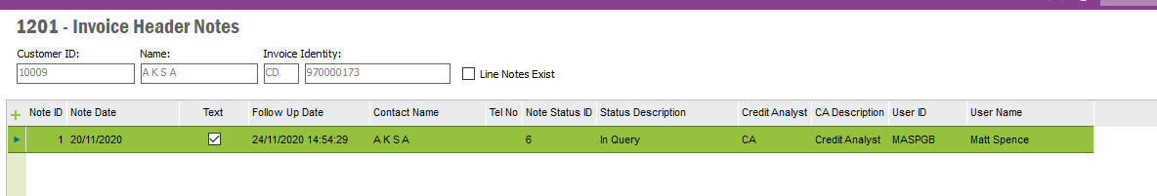

**Creating Query from Customer Analysis screen.**

CRIM 0343 details creating an Invoice Credit Header Note from this screen by selecting one or many Invoices, RMB on those items and selecting “Add Credit Note”. To which a dialogue box appears, that is described below (and in CRIM 0343 in more detail). In this Dialogue box an Invoice Header Note can be added as well as a Query Reason (if the Note Status is set to In Query).

**Creating a Credit Note - Dialogue Box**

|  |  |  |  |
| --- | --- | --- | --- |
| **Dialogue Box Fields** | **Field Description** | **Editable?** | **Visible in Dialogue box?** |
| Note ID | Unique Note ID | No. Auto populated based on Note ID number sequence. | Yes. |
| Date | Today’s Date | No. Auto populated. | Yes. |
| Note Text | Free text | Yes. Free text input. | Yes. |
| Follow Up Date  (DD/MM/YYYY) | Auto populated based on Note Status (unless editable).  *Follow-Up Date = Today’s Date + Follow-Up Time* | Event must take place here. If Note Status, has “Allow Manual Follow-Up Date?” box checked in the Note Status table. Then Follow Update is editable. Else, populate field with (Today’s Date + Follow Up Time). | Yes. |
| Contact Name | Contact Name of Customer | No. Auto populated. | Yes. |
| Tel. No. | Customer Tel. No. | Yes. | Yes. |
| Note Status ID | Status ID | Yes. Selectable from a drop-down list, list must also contain corresponding Note Description. | Yes. |
| Note Status Description | Status Description | No. Auto populated from Note Status ID. | Yes. |
| Credit Analyst | Credit Analyst | No. Auto populated with current Credit Analyst. | No. |
| Credit Analyst Description | Credit Analyst Description | No. Auto populated with current Credit Analyst Description. | No. |
| User ID | User ID | No. Auto populated with current User ID. | No. |
| User Name | User Name | No. Auto populated with current User Name. | No. |
| **Query ID** | **Query ID (basic data field)** | **Yes. On the Condition that the Note Status is “In Query”. Otherwise this field is blank. (see CRIM 0392)** | **Yes** |
| **Query Reason** | **Drop down list containing the Query reasons. This data is stored in the Credit Management basic data, Query Reasons tab.** | **Yes. On the Condition that the Note Status is “In Query”. Otherwise this field is blank. (see CRIM 0392)** | **Yes.** |

Once the dialogue box is saved, the note data is saved in the “Invoice Header Notes” screen. As shown in the screenshot below. If multiple invoices are selected then the same Invoice Header Note are added to multiple Invoice Header Notes screens.

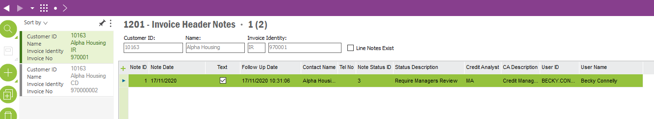

# Technical.

Field Definitions.

<New Field/CLU Definition>

|  |  |  |  |  |  |  |
| --- | --- | --- | --- | --- | --- | --- |
| New DB Object Name | DB Object Item/Field Names | Item Description | Item Data Type | Item Syntax | Calculation Spec, if Derived | LOVs/Enums/Is Mandatory? |
|  |  |  |  |  |  |  |
|  |  |  |  |  |  |  |
|  |  |  |  |  |  |  |
|  |  |  |  |  |  |  |
|  |  |  |  |  |  |  |
|  |  |  |  |  |  |  |
|  |  |  |  |  |  |  |
|  |  |  |  |  |  |  |
|  |  |  |  |  |  |  |
|  |  |  |  |  |  |  |
|  |  |  |  |  |  |  |
|  |  |  |  |  |  |  |

Security

<Define security controls> (Who needs access to this and will it be restricted from any other users etc)

|  |  |
| --- | --- |
| **Role** | **Permissions** |
| Finance Manager | Full |
| Credit Manager | Full |
| Credit Analyst | Create Permissions.  Cannot create a note with Status 3 (Credit Manager Resolved). |

Companies

Applies to the following companies. All.

|  |  |
| --- | --- |
| **Company** | **Required (Y/N)** |
| 1201 | Y |
| TBC |  |
|  |  |

Data Migration

<Describe any data migration impacts this development may have – i.e additional data to be migrated>

Test Steps

<Steps that needs to be taken to test this change. Please provide expected results> Updated post solution.

|  |  |  |
| --- | --- | --- |
| **No** | **Script\Test Steps** | **Expected Result** |
| 1 | Go into Invoice Header Note Screen. | See the Query ID and Query Description Columns. |
| 2 | Add a note from the Invoice Header Note screen | If Note Status 19 is selected then the Query Status drop down becomes editable. If any other note status is selected the Query fields are not editable and remain blank. |
| 3 | When Credit Note Status 19 is selected on a note and a Query ID and Reason are input. | The Follow Up Date needs to be updated to reflect the Query Follow Update. |
| 4 | When creating a note from the Customer Analysis screen, when in the Note Creation Dialogue box (CRIM 0343) | Be able to add a Query Reason/Query ID to an Invoice Credit Header Note. |
|  |  |  |
|  |  |  |

Technical Implementation

**Note: This section contains custom objects required by both CO343 and C0392 as these two CRIMs are interconnected**

This implementation uses following custom objects;  
  
**Custom Fields:**  
  
Credit Management Basic Data – Notes Status Window

Allow Manual Follow Up Date – CF$_ALLOW_MANUAL_FOLLOW_UP

Follow Up Time (Working Days) – CF$_FOLLOW_UP_TIME

Inc. in Call List for Analyst – CF$_INC_IN_ANALYST_LIST

Inc. in Call Lists for Manager – CF$_INC_IN_MANAGER_LIST

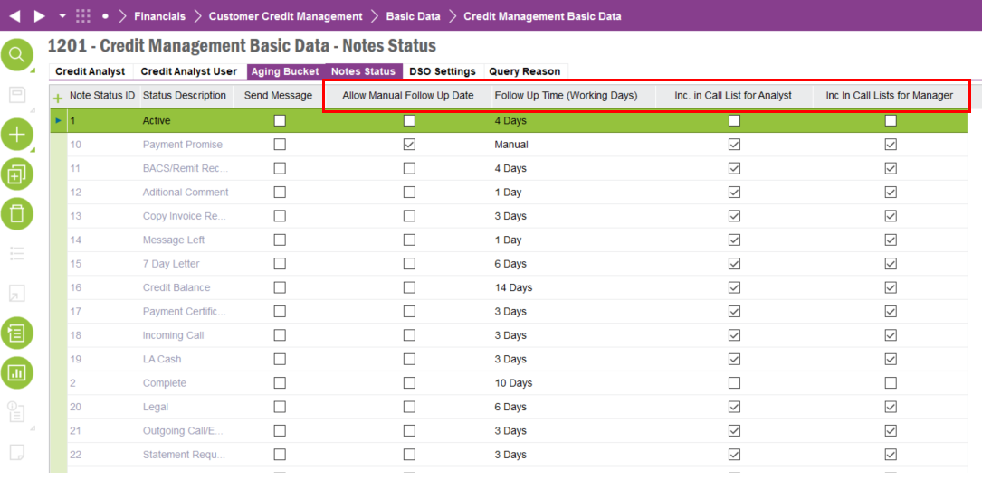

Custom Analysis Window

Bulk Update – CF$_BULK_UPDATE

Bulk Update User – CF$_BULK_UPDATE_USER  
  
Note: Bulk Update User field is only used by the underline logic and is not required to be visible to the user.

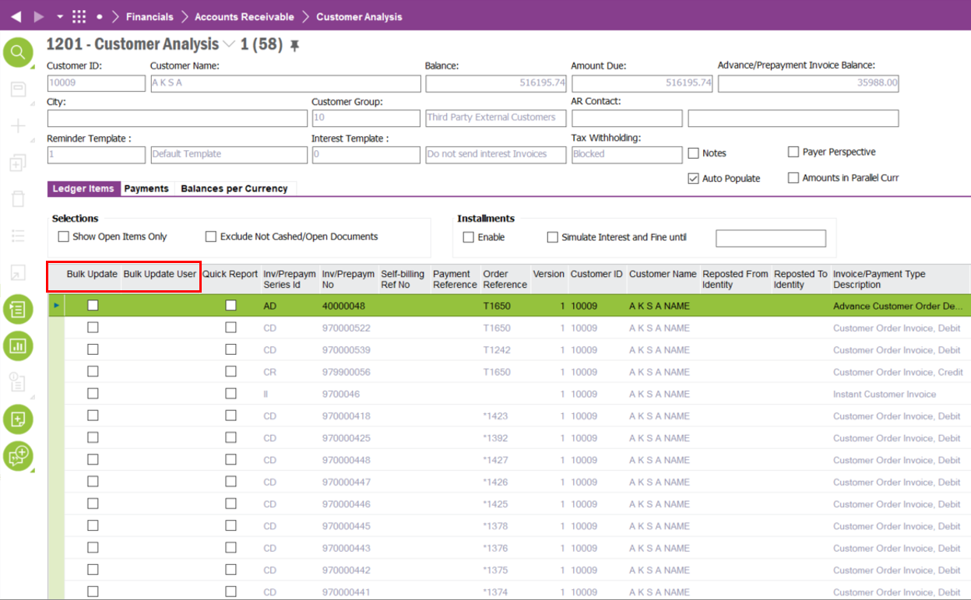

Invoice Header Notes Window

Bulk Update – CF$_BULK_UPDATE

Bulk Update User – CF$_ BULK_UPDATE_USER

Note Text – CF$_ NOTE_TEXT

Query ID – CF$_ QUERY_ID

Query Reason – CF$_ QUERY_REASON

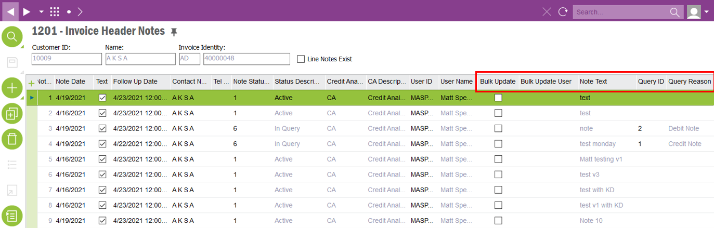

**Custom Logical Units:**

InvoiceHeaderNotesExt

This LU is used by the internal logic and should not be exposed to the end user

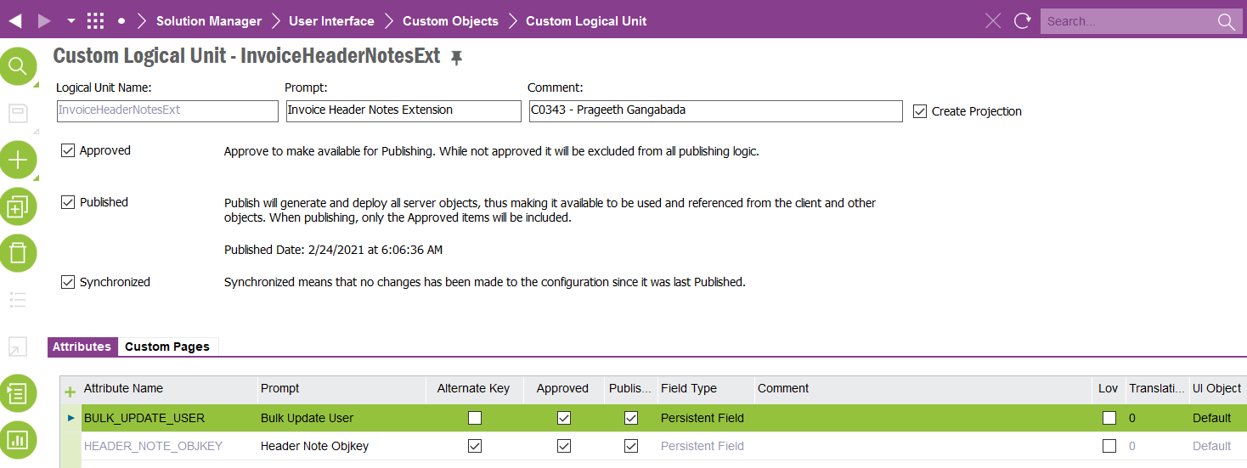

LedgerItemExt

This LU is used by the internal logic and should not be exposed to the end user

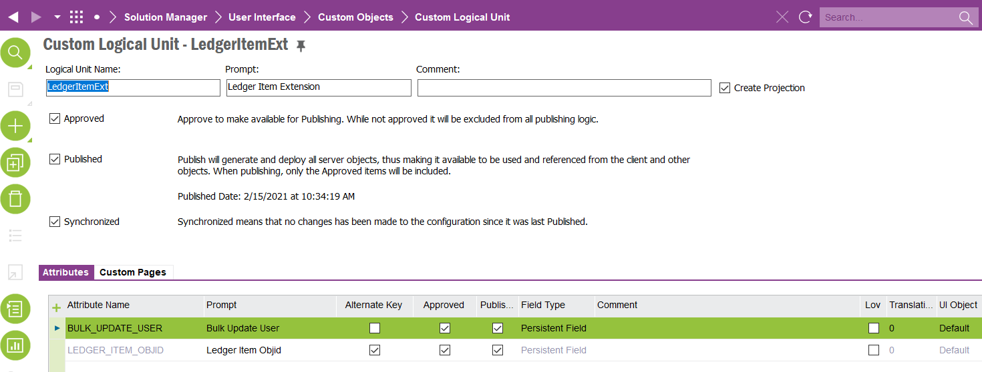

**Custom Menus:**

Custom Analysis Window

Select for Bulk Update : Mark the selected record as a bulk update record ( to update notes and status of all Invoice Header Notes connected)

Add Credit Note to Invoice… : Navigate to the ‘Invoice Header Notes’ window

Bulk Update Notes : Update Notes of all the ‘Bulk Update’ checked records with the last added notes

Clear Bulk Update : Uncheck ‘Bulk Update’ flag in case user decides to cancel updating notes

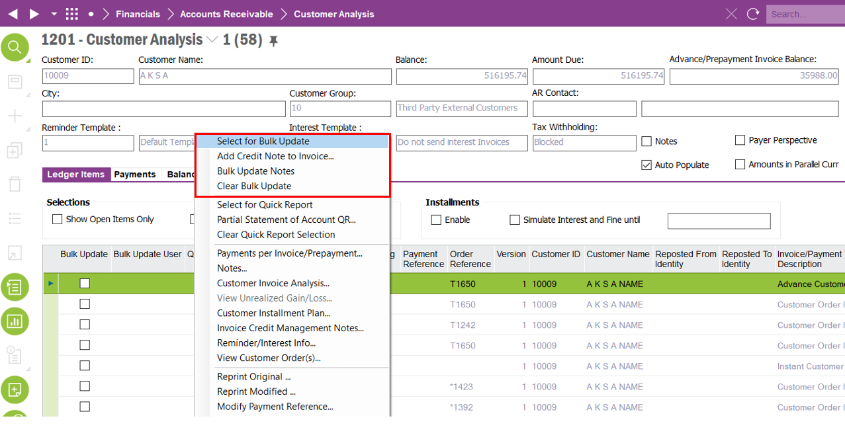

Invoice Header Notes Window

Bulk Update Notes : Update Notes of all the ‘Bulk Update’ checked records with the last added notes

Clear Bulk Update : Uncheck ‘Bulk Update’ flag in case user decides to cancel updating notes

Note: Both these RMB options performs the same operation as the custom RMBs in the Customer Analysis Window.

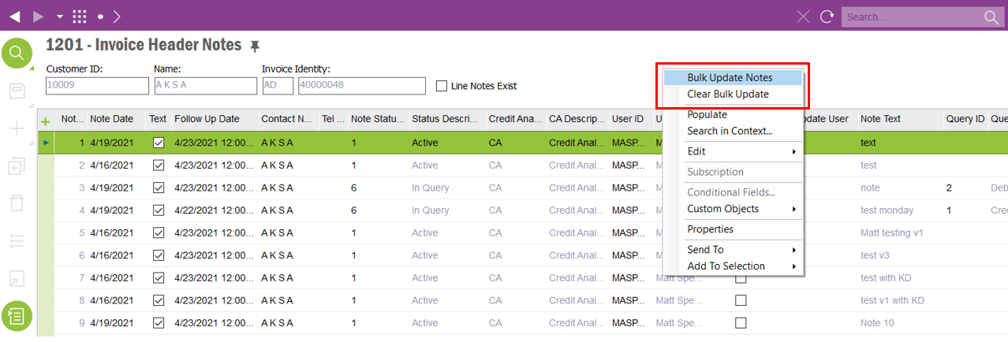

Refresh Follow Up Date: Follow Up Date is updated by a background job once a record is added or modified. This might take a while depending on how the background job is picks up by the connected batch queue. User can use this RMB to instantly get the ‘Follow Up Date’ updated

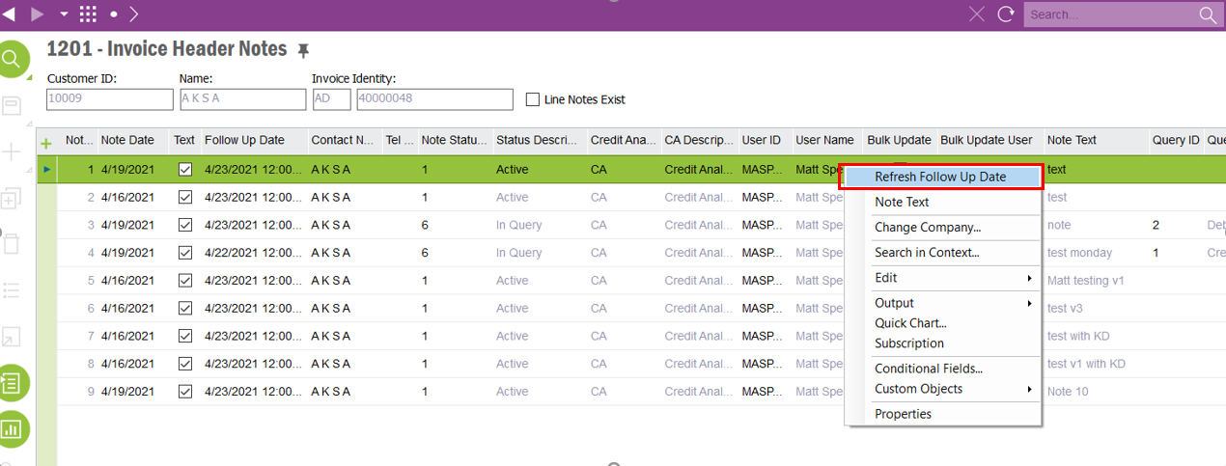

**Custom Events:**

INVOICE_HEADER_NOTES_EXT : This event creates a record in invoice_header_notes_ext_clt table to store whether the record is part of a bulk update operation and the user carrying out the bulk update

INVOICE_HEADER_NOTE_DATE: This event updates the "Follow Up Date" of invoice header notes depending on the selected "Note Status"

INVOICE_HEADER_NOTE_DATE2: This event updates the "Follow Up Date" of invoice header notes depending on the selected "Query Note"

**Conditional Fields:**

Invoice Header Notes Window

Follow Up Date: Field is only editable manually when ‘Note Status’ is set to ‘Require Managers Review’

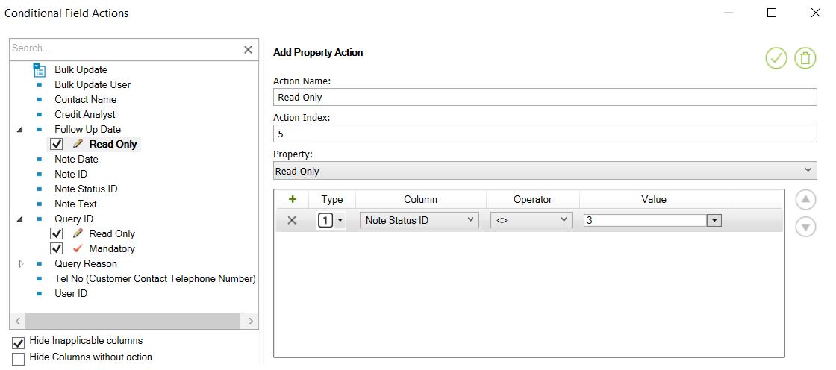

Query ID: Query ID can only be modified when the ‘Note Status’ is set to ‘Query Reason’

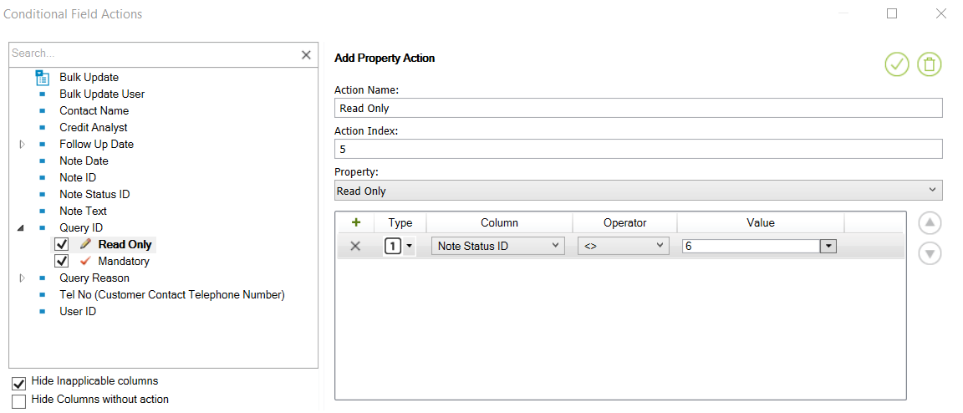

Query ID: Query ID is mandatory when the ‘Note Status’ is set to ‘Query Reason’

